Be your own stylist

WHAT COLOUR IS YOU
You don’t need to spend couple of hundred pounds for someone to tell you what colours fit you the most, of course if you doing financially well, you wouldn’t mind that, it is fun to have an appointment with the stylist and learn from someone who knows what they doing.
I’m a stylist and I wouldn’t say my job is not important , my job is extremely rewarding and I helped hundreds of people to change their buying habits and wardrobe look so they can finally safe the money when they go shopping and buy for purpose not for fun. Clothes are expensive items and unless you know what you doing, then you not throwing any money out the window. Each of us should be aware of what colours suit them but many people still buying the wrong ones.
Figuring out your colour palette is easier than you think and once you know the basics, you can fill up your wardrobe with pieces that really suits you. The process of finding your colour is based on 3 step process:
- Find if your cool or warm; check your veins, if they are blue then your skin tone is cool, if they green you are warm
Second option, put silver and gold near your face; if silver suits your better your cool, if gold suits you better your warm
BLUE VAINS/ SILVER COLOUR= COOL
GREEN VAINS/ GOLD COLOUR = WARM
- Find what season you are. Here are some help for you to figure that out. It’s very simple. You have to look at your eyes skin and hair colour.
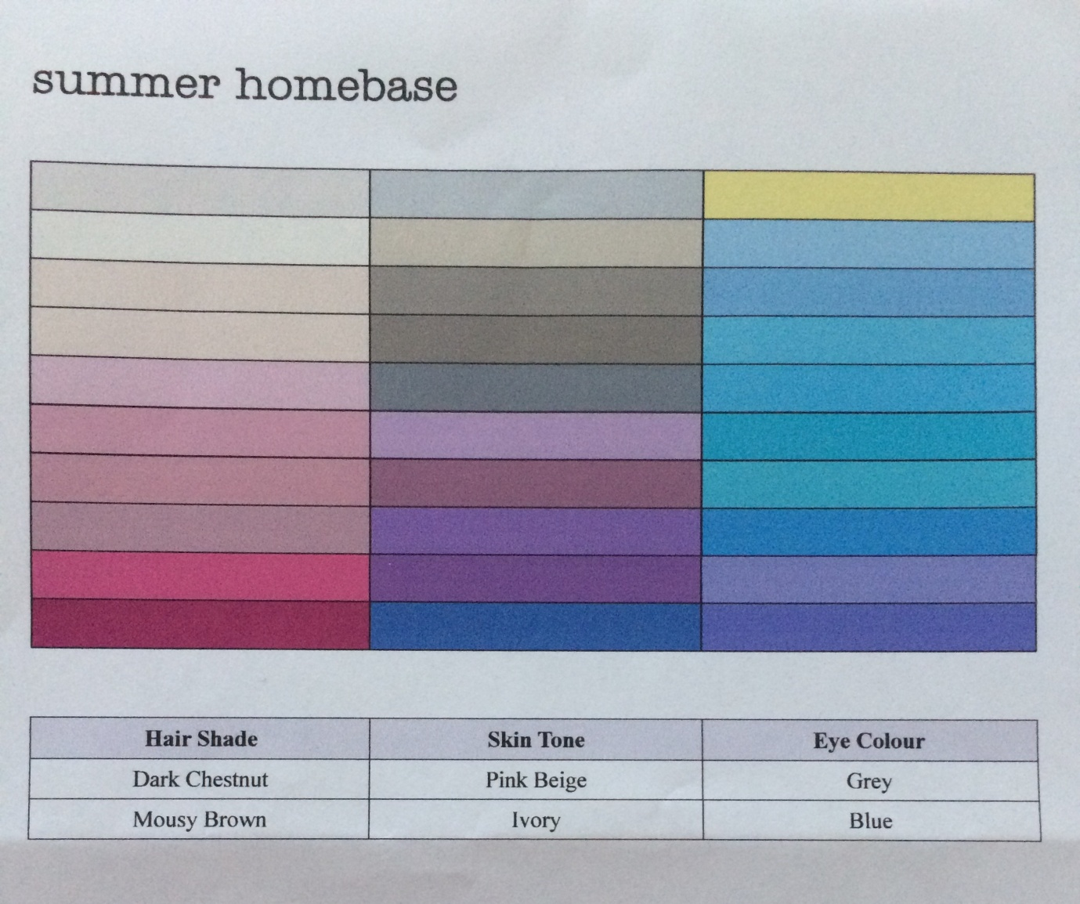

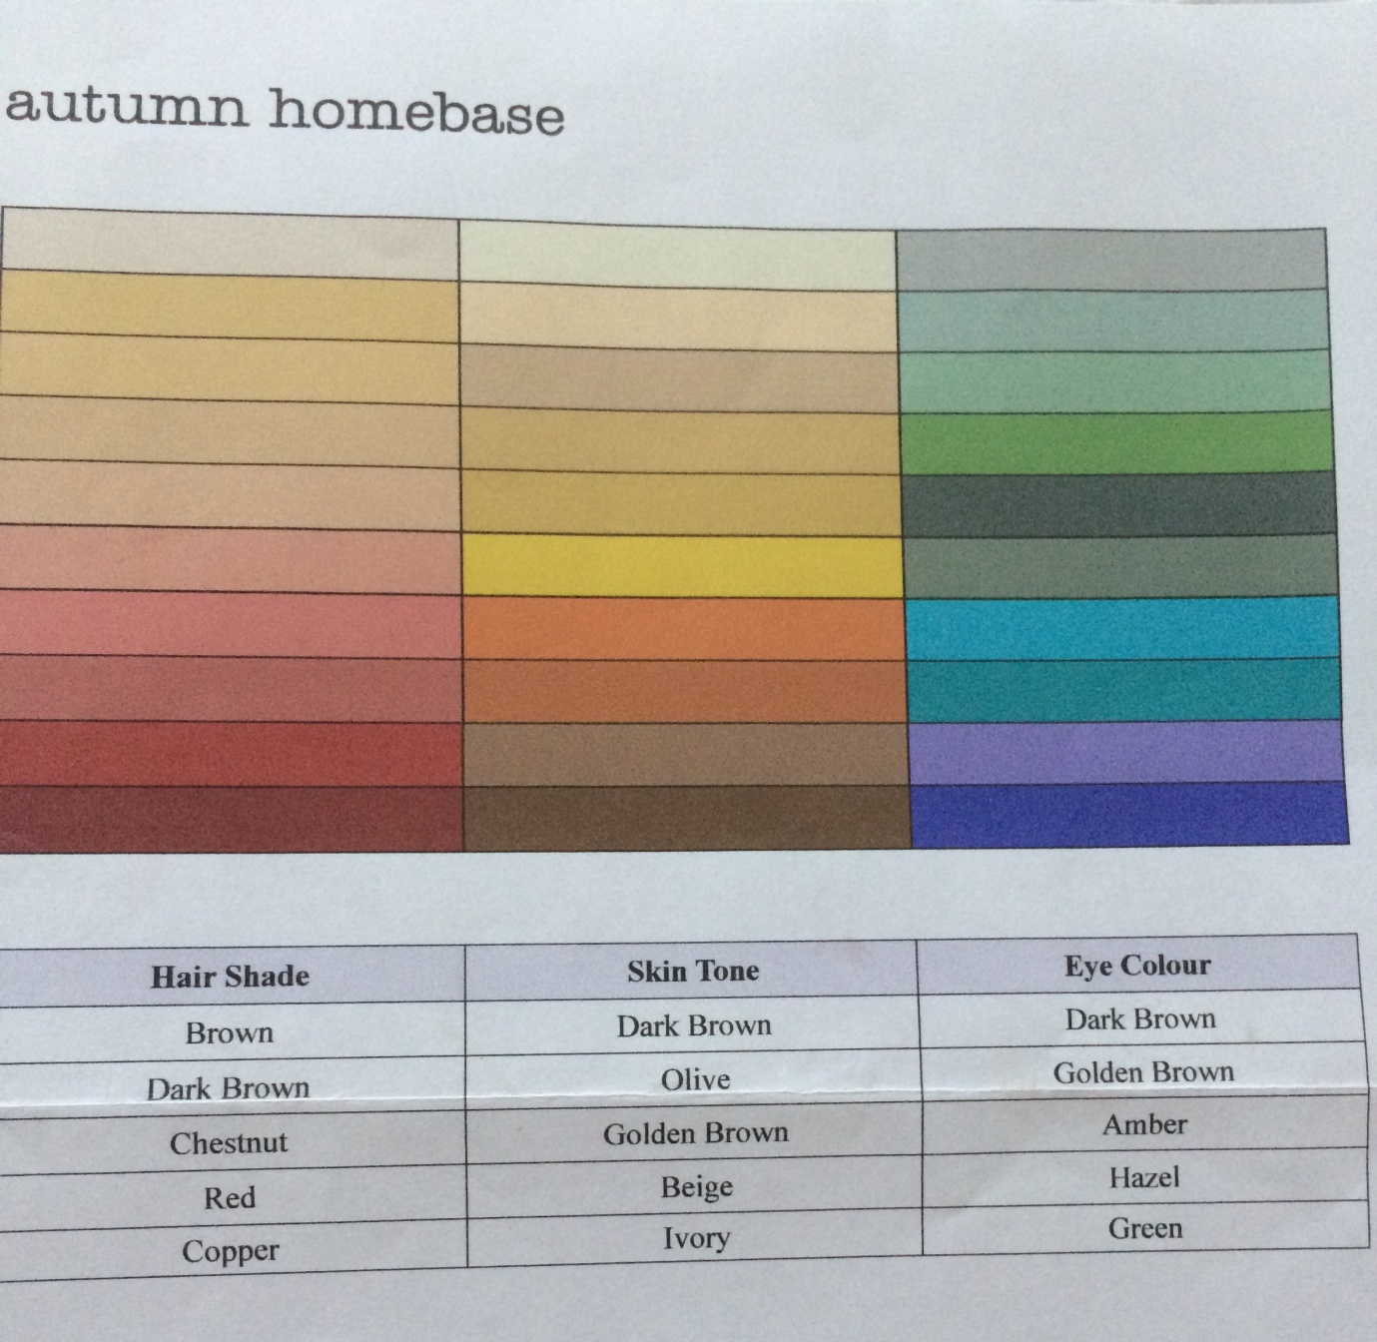

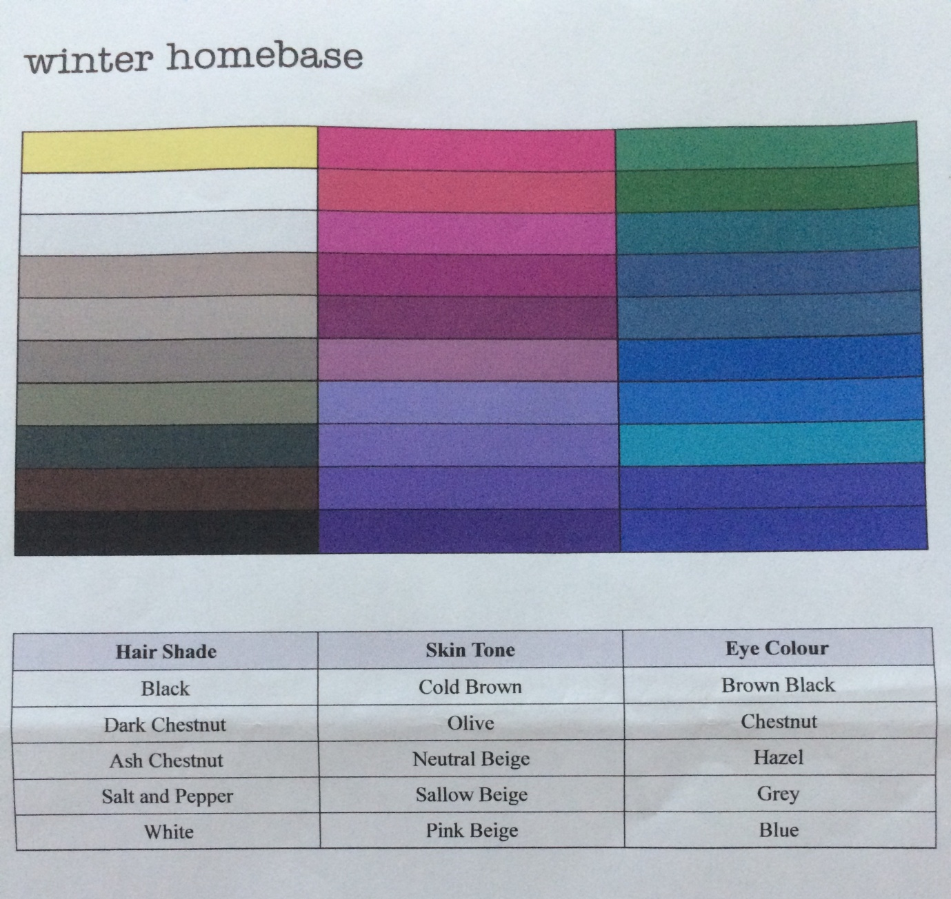

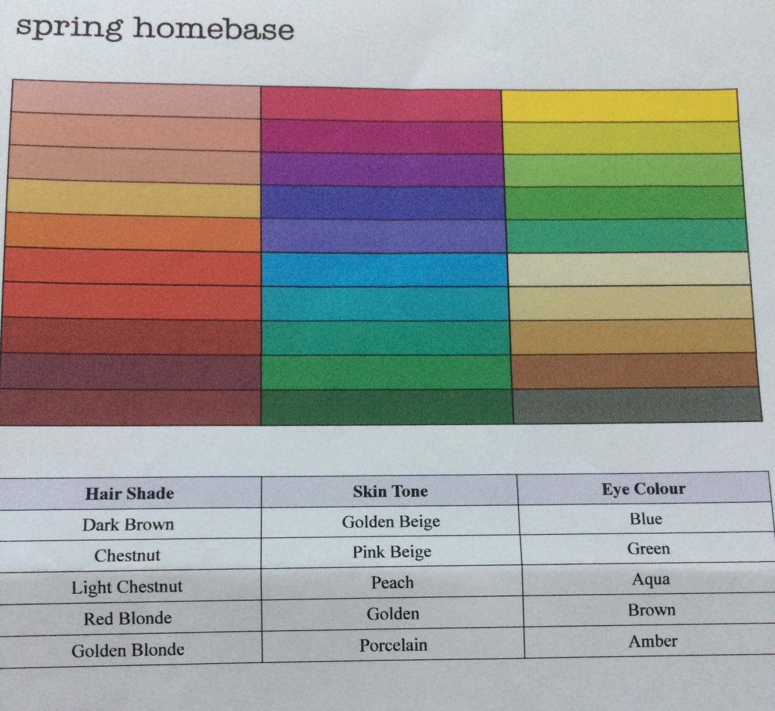
3.Season with an influence ; sometimes it happens that your hair colour and eyes does not match the criterias in the tables shown, like for example having copper hair and grey eyes. That means you are a season with influence of another season. You will be defined as autumn (based on your hair colour) and winter (based on your hair colour)in this case you have to look at both autumn and winter colours but concentrate perhaps more on the makeup palette for this.

4. What type of season you are; there is 4 main seasons and each of them has 3 traits
For example Autumn season can be ; Warm, Deep or Soft, Winter can be; clear, deep or cool. Here are some links to the palettes of this seasons .
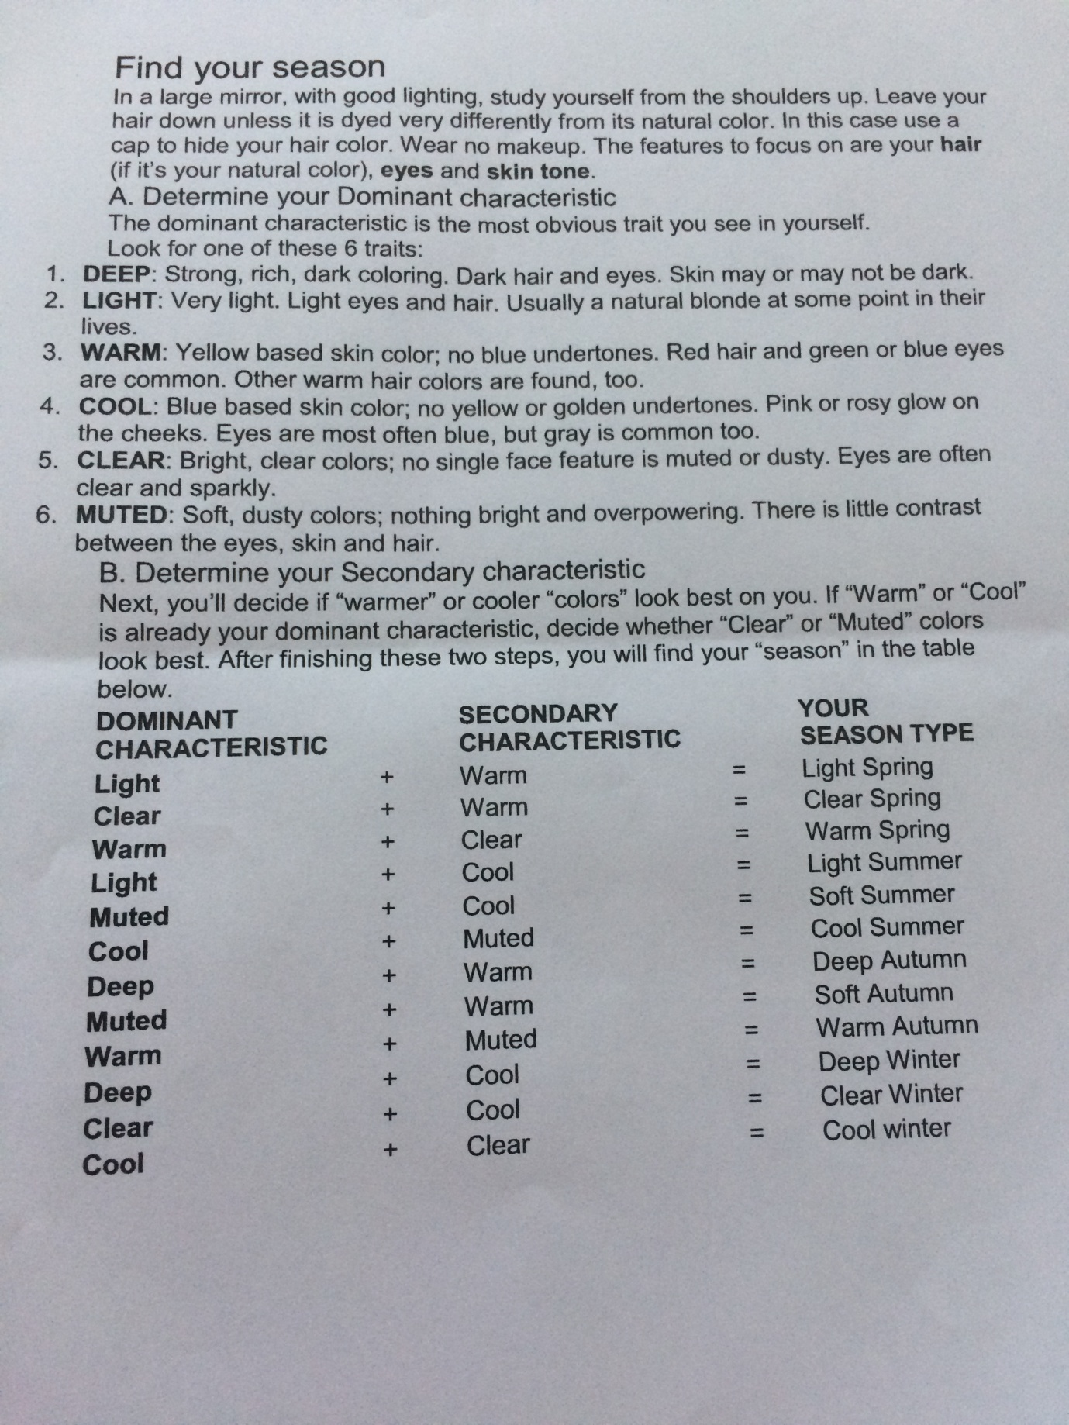
I attached some links below which should help you identify that easy way

http://cardiganempire.com/2016/03/best-worst-colors-for-autumn-seasonal-color-analysis.html

http://cardiganempire.com/2017/03/best-worst-colors-for-winter-seasonal-color-analysis.html

http://cardiganempire.com/2017/08/best-worst-colors-for-spring-seasonal-color-analysis.html

http://cardiganempire.com/2017/02/best-worst-colors-for-summer-seasonal-color-analysis.html

So you know already what season you are and what palette of colours suit you. That’s the first step to the shopping guide. Now you need to know how to mix the colour together. If you just a beginner choose max 2 colours

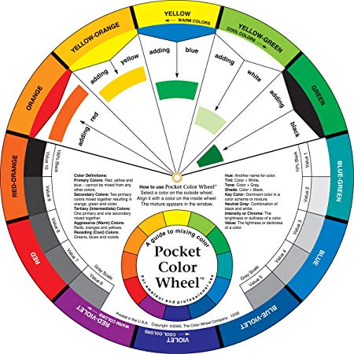
What will help you with that is a colour wheel, print out one from the internet or purchase original one on amazon or ebay. The colour wheel showing you how to mix colours together, which one look together good and which one not. If you starting out choose colours which are next to each other on the colour wheel. Choose the basic one for the main piece of clothing like coat, blazer, trousers or skirt, choose the bright colour for the clothes like top or accessories such as scarf, bag, or shoes. Once you get used to trying out new combinations, move onto the more brave choices. Look at the colour wheel again and try to mix colours which are opposite eachother like purple and yellow, green and red,
If you still not sure, already knowing your palette type in google what goes with green, what goes with red, what goes with yellow and so on. It will give you a lot different looks and probably inspire you to be more brave with your choices.
I hope you enjoy this read and you have taken your first step to become your own stylist and creating your perfect wardrobe.

